|  |  |  |  |
| --- | --- | --- | --- |
|  |  | |  |
|  | | **JSW INFRASTRUCTURE LTD.** | | |
|  | |  | | |
| **Momentum Score** | | 1.42 | | |
|  | |  | | |
| **Technical Analysis** | |  | | |
| **Daily** | | UP | | |
| **Weekly** | | UP | | |
| **Monthly** | | Consolidate | | |
|  | |  | | |
| **Fundamental Analysis** | | Strong Fundamentals | | |
|  | |  | | |
| **Recommendation** | | BUY | | |

**SMIF REPORT**

**JSW Infrastructure Ltd**

|  |  |
| --- | --- |
| BSE: | [543994](https://www.bseindia.com/stock-share-price/jsw-infrastructure-ltd/JSWINFRA/543994/) |
| NSE: | JSWINFRA |
| NIFTY 50: | 24,811 |
| SENSEX: | 81,053 |
| CMP: | ₹ 313 |
| RECOMMENDATION : | BUY |
| DATA: | AUG 22, 2024 |

|  |  |
| --- | --- |
| Market Cap | ₹ 65,667 Cr. |
| Enterprise Value | ₹ 66,335Cr. |
| Book Value | ₹ 38.2 |
| Face Value | ₹ 2 |
| Promoter holding | 85.6% |

|  |  |
| --- | --- |
| ROE | 19.0 % |
| ROCE | 16.4 % |
| ROA | 9.95% |
| Debt to equity | 0.59 |
| EPS | ₹ 5.37 |
| PE | 58.3 |

|  |  |
| --- | --- |
| **Momentum (90 days )** | **1.42** |
| **QoQ sales ( compare to last )** | **-7.84%** |
| **QoQ profit (compare to last )** | **-9.7%** |
| **YOY- Quarterly sales growth** | **14.99%** |
| **YOY- Quarterly profit growth** | **-8.87%** |
| **3Years sales CAGR** | **33%** |
| **3Yrs profit CAGR** | **59 %** |
| **Cash flow from operating** | **March-23= 1797 cr. March-24= 1803 cr.** |
| **Net Cash Flow** | **March-23= 90 cr. March-24 = 105 cr.** |

**STOCK PERFORMANCE CHART**

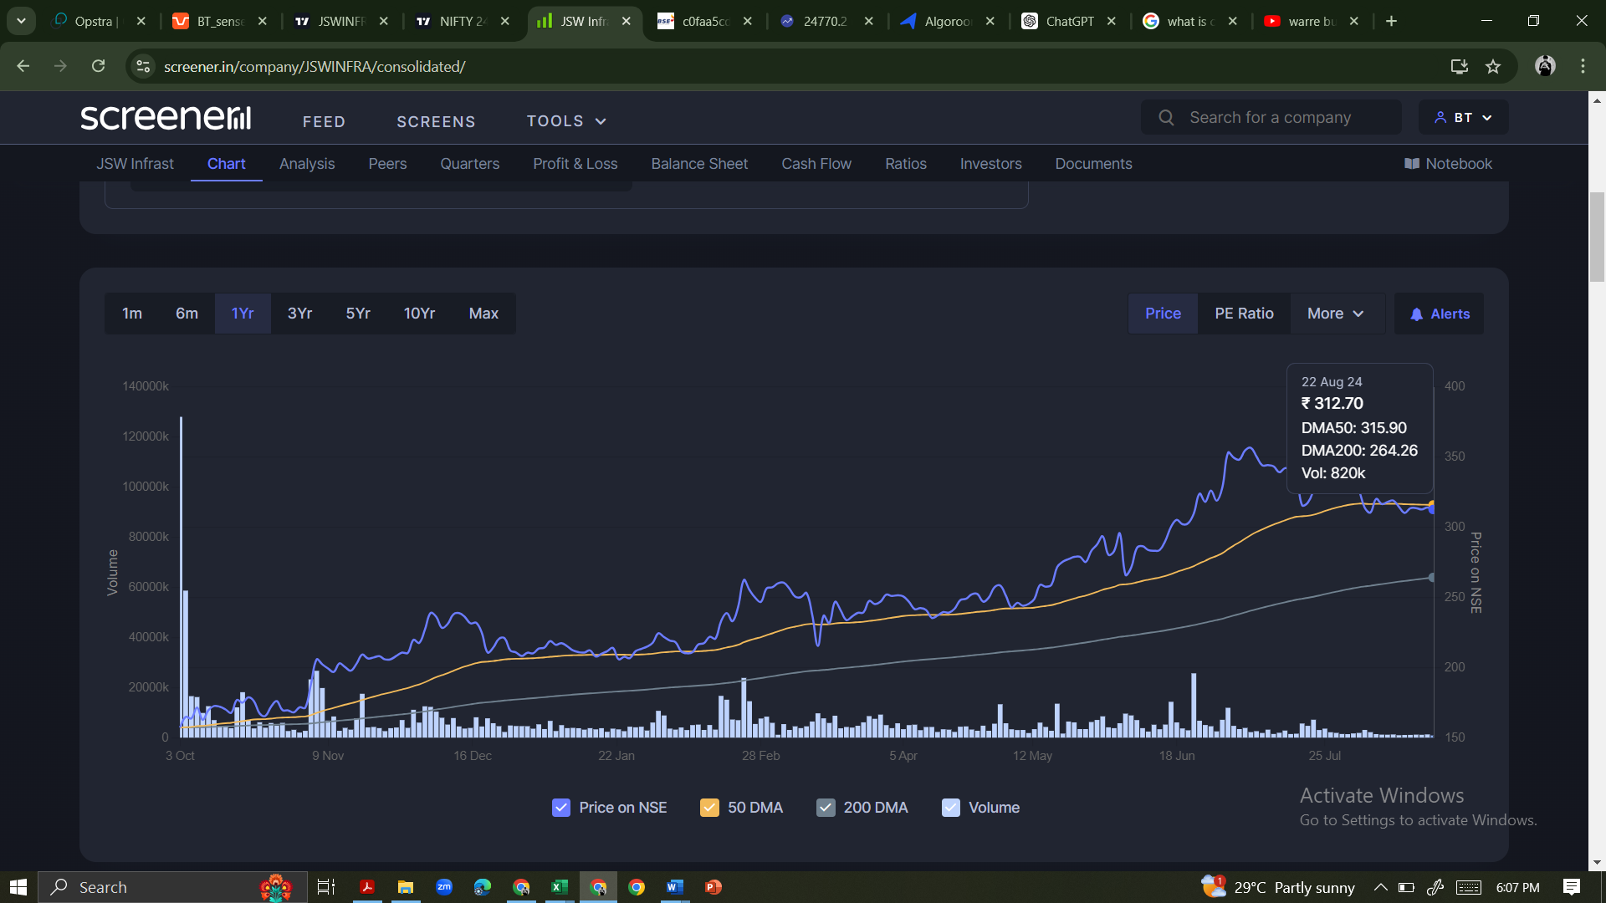

**Technical Analysis**

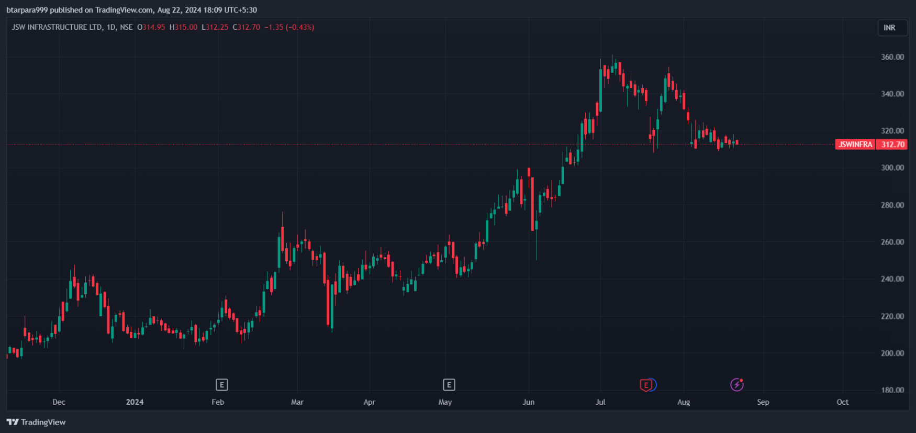 (**1) Daily**

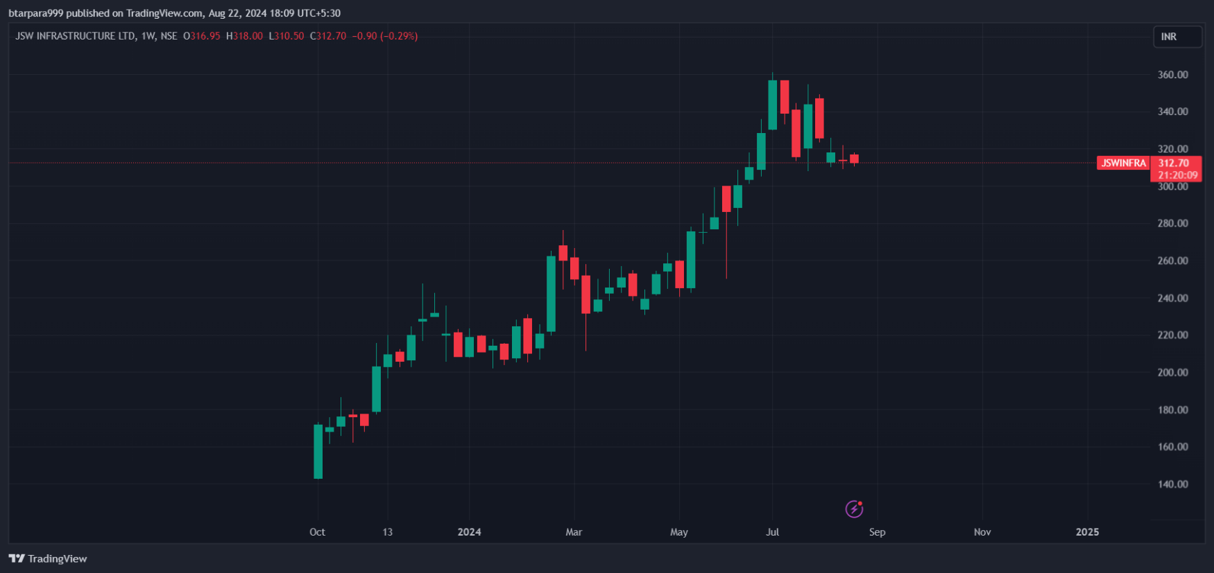**(2) weekly**

**Bhautik Tarpara**

**(3) Monthly**

